A Weekly Newsletter of Nu‘uanu Congregational Church
NCC News
December 20, 2020

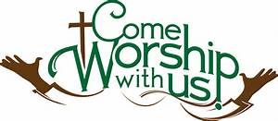

Annual Reports Due
To all board and committee chairs, Moderator, and Pastor, please submit your annual reports to Mairi Manley by December 18 via email. Adhering to this deadline will be most appreciated. Reports should be in Word or Pages format, Century Schoolbook font, size 12. Any photos should be sent separately (not within the report). Mahalo.

2020 Contributions
Just a reminder....in order for contributions to be credited for the 2020 tax year, they must be either mailed to the church with a USPS postmark not later than December 31, 2020 or received by the church office before 12:00 p.m. Thursday, December 31, 2019. Contributions received after that will be credited to 2021.

Give Aloha – Mahalo!
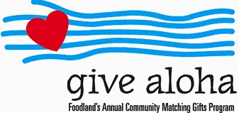
Your Foodland receipt with your name on it must be received by the church office by December 31, 2020, so we may properly credit your giving account for the 2020 tax year. Receipts received after December 31 will be credited to 2021. Foodland does not provide us with any names. Also, please make sure that the date, time, and store is on the receipt. That is the only way we are able to verify your giving with the printout provided by Foodland. There are approximately 5 outstanding receipts remaining. Mahalo.

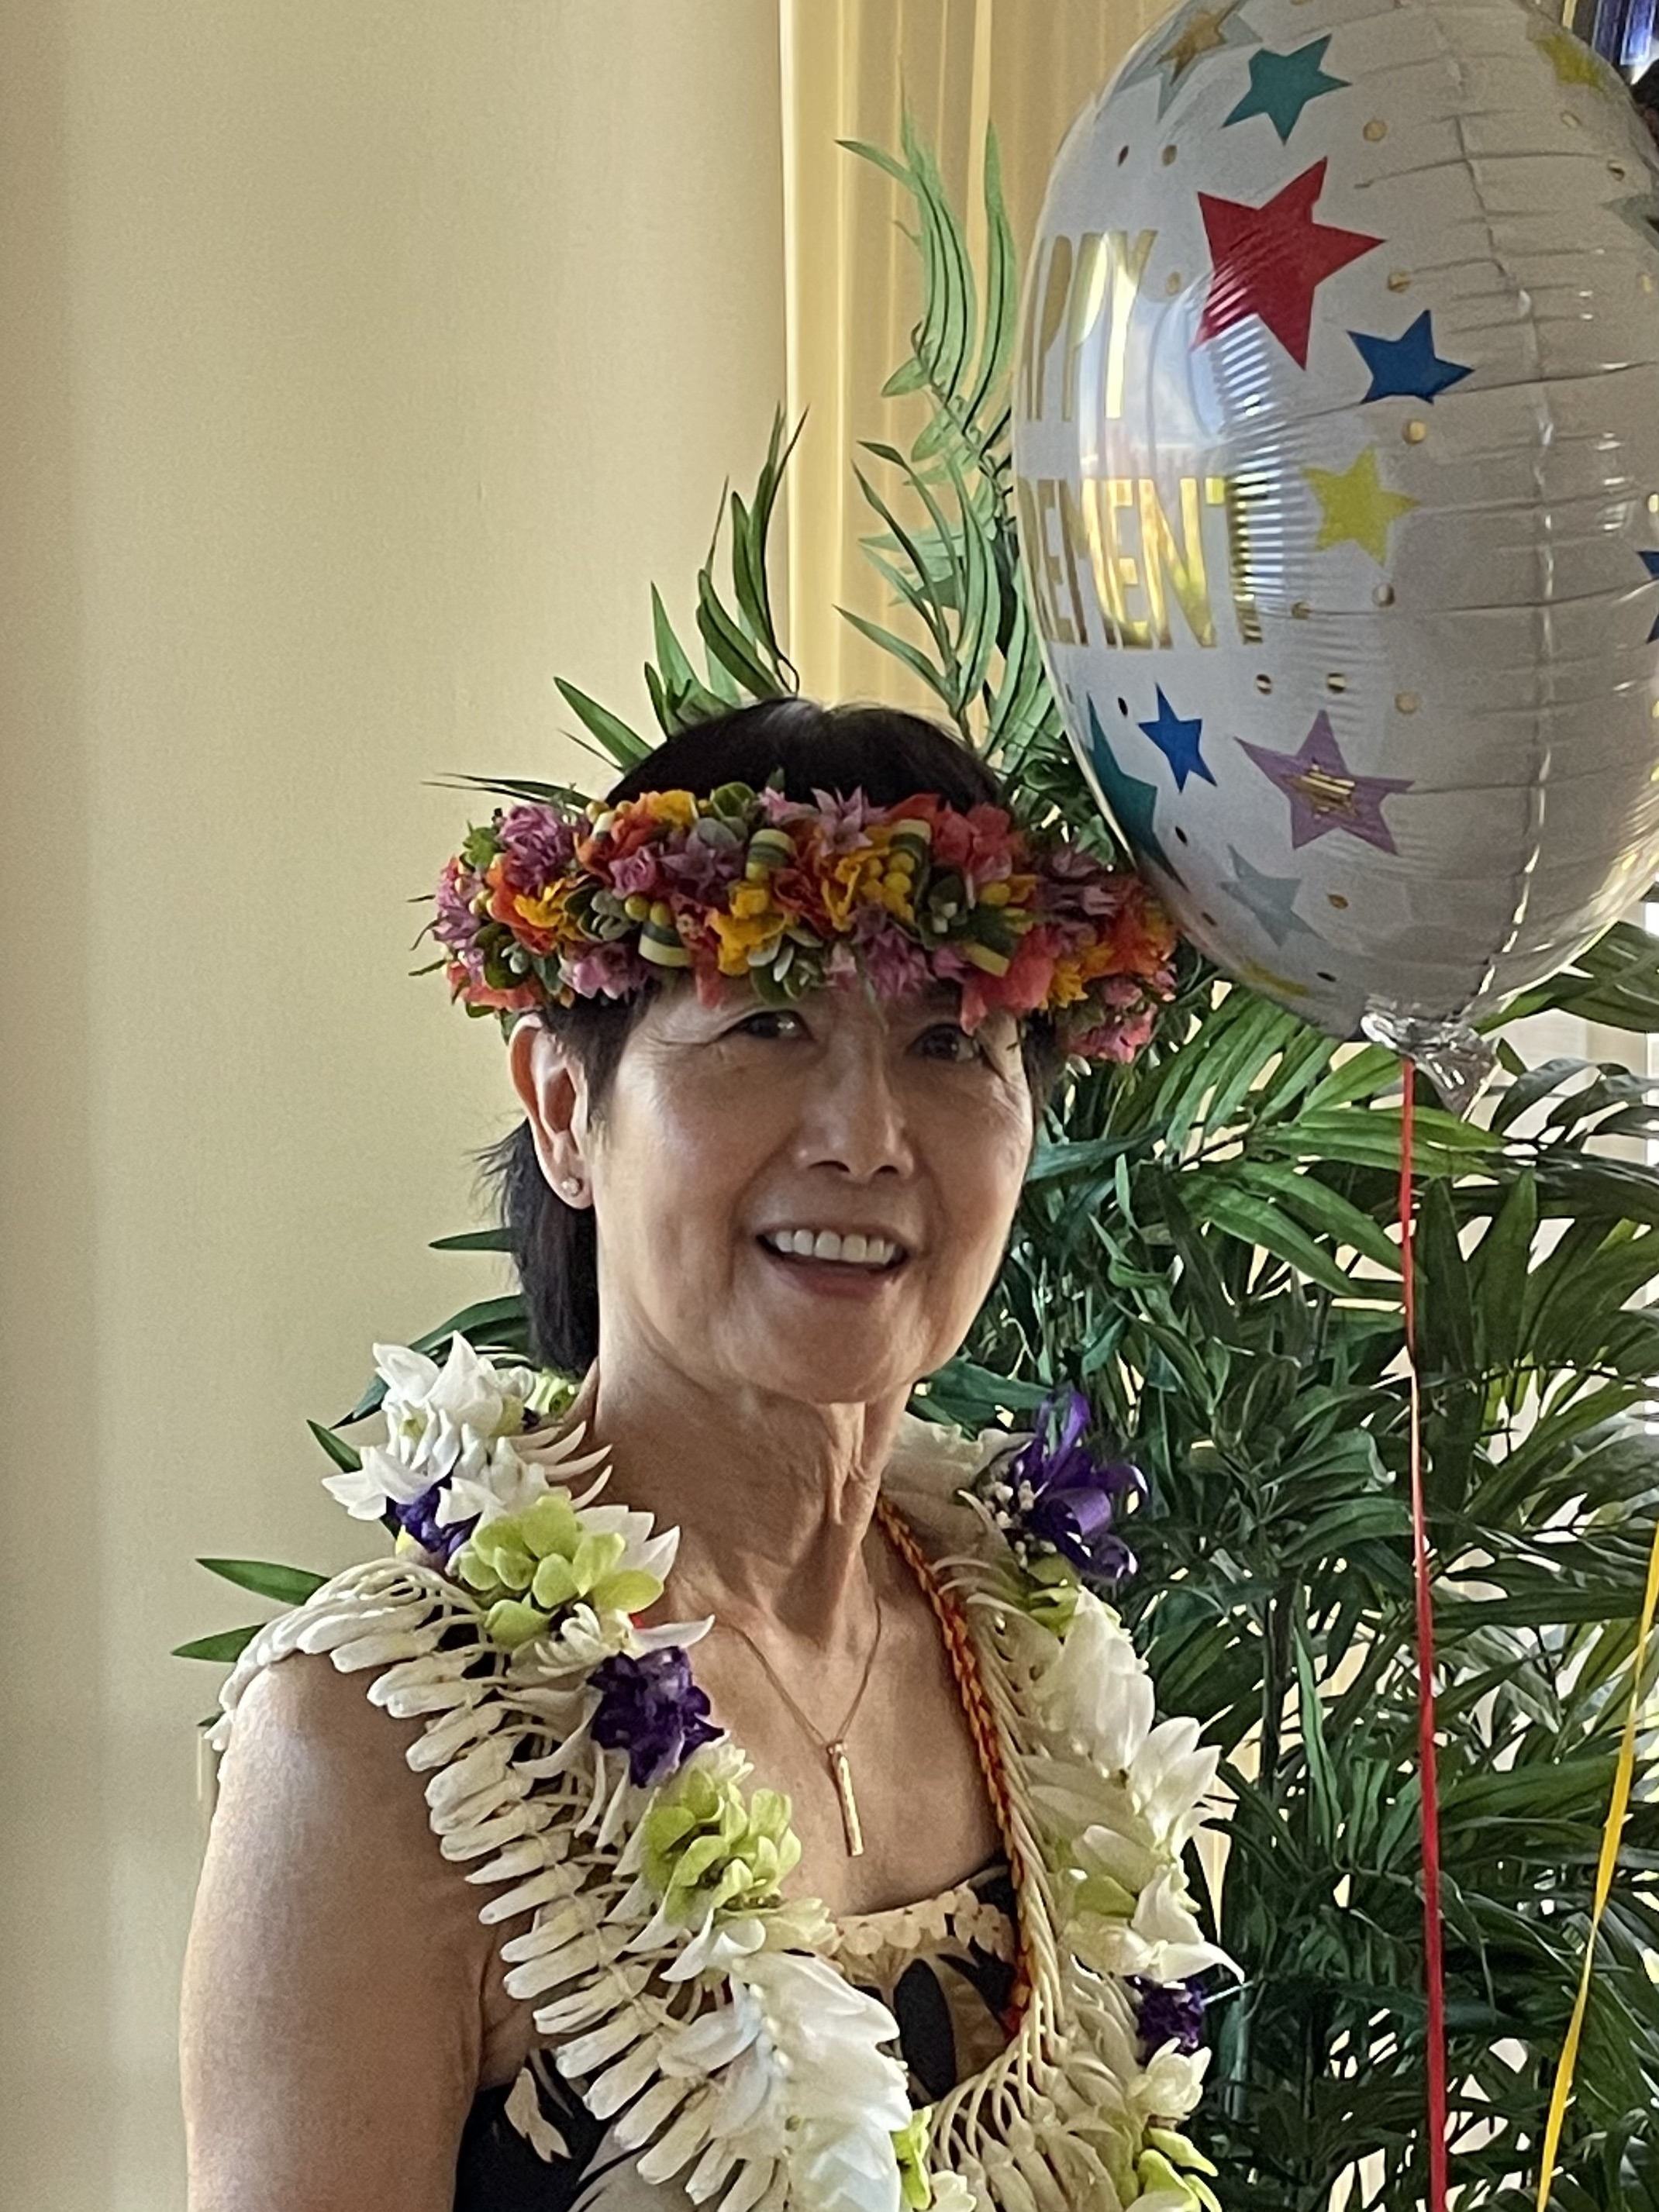
Dear Members and Friends,
I was truly overwhelmed by all the love and appreciation shown to me in this past Sunday's (12/6/20) drive-by. The number of folks that came out were more than I expected! Thank you, Council (and especially Lori Yamashiro), for organizing and coordinating this special retirement event! And thank you, everyone for taking the time from your day to drive to church, your generous gifts, lei, balloons, and loving and appreciative words! I also love ❤ the Hawaiian Heritage pendant that was given to me on behalf of the church. It is so beautiful! I will wear it with many fond memories of my time in the office. I’m waiting for the day when this pandemic subsides, and we can see each other in person once again. Until then, keep safe and healthy! Mahalo nui loa!
Love,
Paula

White Christmas
Covid-19 will not diminish the spirit of Christmas sharing. More than ever, we need t lift up our homeless families. As we did last year, we ask that you donate gift cards (i.e: Target, Walmart, Longs Drugs, etc.) that we can distribute to the UCC Transition house, River of Life Mission, and Family Promise. Please indicate the amount on the card, so we can distribute them equally. Mail or deliver them to the church office. Donations will be accepted December 1-19. Mahalo and Mele Kalikimaka.

January NCC Caller
This is a friendly reminder that if have any articles for the January Caller, please send the articles to Mairi Manley by December 20, 2020 at nccadmin@hawaiiantel.net.

Christmas Eve Service
This year, we are having a “Drive-in” Christmas Eve Service at 7 p.m. There will be 35 car spaces in the lower parking lot available. Make your reservation by calling Mairi Manley at office at 595-3935 or email her at nccadmin@hawaiiantel.net. Thank you to everyone who has helped to make this service happen. Mele Kalikimaka.

