A Weekly Newsletter of Nu‘uanu Congregational Church
NCC News
November 8, 2020

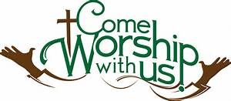

Give Aloha – Mahalo!
Mahalo to all who participated in Foodland’s Give Aloha Program last month. We will be receiving all of your contributions and Foodland’s grant some time in mid-October.

Please mail your receipt with your name on it to the church office, so we may credit your giving account properly. Foodland does not provide us with any names. Also, please make sure that the date, time, and store is on the receipt. That is the only way we are able to verify your giving with the printout provided by Foodland.

Continue to keep safe, and help NCC continue their ministries in the community! Thank you in advance for your contribution!
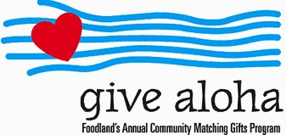

Blessings and Blessings—November 1st … AT CHURCH!

November 1st is a special day in the life of our church.
It is Communion Sunday, and it is All Saints Sunday.
To make it a special day and memorable day, we have decided
to welcome all to come to church that day for

59th Nu’uanu Valley Interfaith Thanksgiving Service
Tuesday, November 24, 2020, 7:00 pm
Historic Virtual Event

When: Tuesday, November 24, 2020 7:00 pm Free & Open to the Public

Where: Virtual Zoom Event

2020 Theme: “Bound in Light”

Zoom login information for 11/24
+1 253 215 8782

Meeting ID & Passcode
Meeting ID: 956 5898 7545
Passcode: 523922

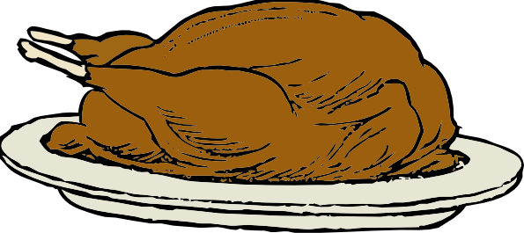

Imu-licious Turkeys
Our friends at City Church of Honolulu have asked for help acquiring turkeys to feed less fortunate families this Thanksgiving. They are getting a crew together to cook them in an imu. So, if you have a Foodland Maika’i Rewards turkey coupon you can share please mail it to the church office. Pastor Jeannie will get them to the City Church folks. Mark the envelope: Pastor Jeannie: Turkeys. If you would also like to help out with the imu, we will have more information soon.

Got Your Flu Shot?
As we enter the flu season, be sure to get your flu shot!

Maybe you think because you are hardly leaving the house, you can skip your flu shot this year? This is a year that we all need to do everything that we can to stay safe and healthy. Even a common flu strain can land you in the hospital, and we need to avoid putting any additional strain on our hospitals this year. Plus, the flu is no fun, and you just don't want to get sick. If you are 65 or older, ask your pharmacist about the enhanced flu shot. And call soon, as it is in short supply. - Judy Keith, Parish Nurse

Church Office
The church office has reopened. Keeping our staff safe is a high priority, so please adhere to this protocol. If there is any business that needs to be conducted, please email it to nccadmin@hawaiiantel.net or call the church office for an appointment. If you need to see Pastor Jeannie, she can be reached at 353-1387. Postal and commercial deliveries will be allowed. Face covering is required by anyone entering the office. Before entering the office, please conduct the self-assessment that is posted on the window adjacent to the door. Also, not more than 4 people, including staff, should be in the office at a time. Thank you for your cooperation in keeping everyone safe as possible!

