A Weekly Newsletter of Nu‘uanu Congregational Church
NCC News
November 29, 2020

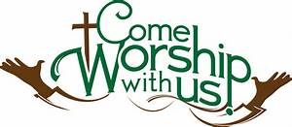

Annual Reports Due
To all board and committee chairs, Moderator, and Pastor, please submit your annual reports to Mairi Manley by December 18 via email. Adhering to this deadline will be most appreciated. Reports should be in Word or Pages format, Century Schoolbook font, size 12. Any photos should be sent separately (not within the report). Mahalo.

2020 Contributions
Just a reminder....in order for contributions to be credited for the 2020 tax year, they must be either mailed to the church with a USPS postmark not later than December 31, 2020 or received by the church office before 12:00 p.m. Thursday, December 31, 2019. Contributions received after that will be credited to 2021.

Give Aloha – Mahalo!
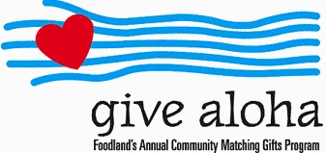
Your Foodland receipt with your name on it must be received by the church office by December 31, 2020, so we may properly credit your giving account for the 2020 tax year. Receipts received after December 31 will be credited to 2021. Foodland does not provide us with any names. Also, please make sure that the date, time, and store is on the receipt. That is the only way we are able to verify your giving with the printout provided by Foodland. There are approximately 5 outstanding receipts remaining. Mahalo.

Imu-licious
Mahalo to everyone who donated their Foodland Maika‘i Rewards Coupon to our friends at City Church of Honolulu. The people who are less fortunate will be appreciative of the turkey meal they will receive on Thanksgiving. We were able to collect 6 coupons for them. Thank you to Stan Chong for coordinating the project!

Neighbors in Need
Thank you to all who participated in the annual Neighbors in Need special offering last month. Our church gathered $844.00, which will support ministries of justice and compassion throughout the country. Bless you for your generosity!

Hawai‘i Foodbank Donations
The Missions Committee will be accepting donations at the church on November 29, 2020 between 10:30 a.m. and 11:30 a.m. Please drop by with any canned goods or monetary donations for the Hawai‘i Foodbank (checks made out to Hawai‘i Foodbank) Don't forget your masks!
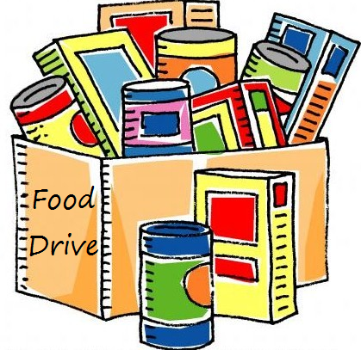

Advent Candle Wreath Supply Pick-up
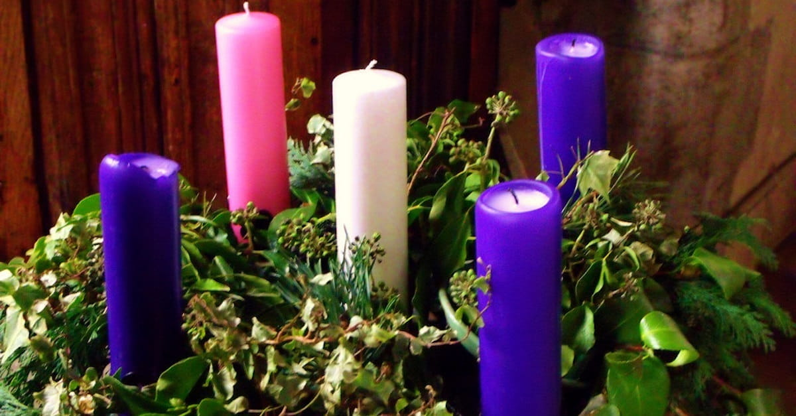
November 29, 2020
Time: 10:30 am to 11:30 am
Where: Nuuanu Congregational Church lower parking lot
What: Advent wreath kits will be available for pickup

Also: Christmas cards for the shut-ins will be available for pickup; along with names and addresses. The Board of Christian Nurture request that you mail your cards to the people you write a card to.
Advent calendars will be passed out to the Sunday School families.
Advent devotional will be available for the adults.

Save the Date!
December 13, 2020 via zoom
We will have a guest speaker from the Samaritan Counseling Center, Rev. Dr. Gary Augustin. He is eager to present and facilitate a discussion group about coping and isolation during the pandemic with the holidays.

Paula’s Retirement
Please Join us on December 6th, during The Communion element pick up to thank Paula for her 14 year service as Administrative Coordinator of the church. Although you won’t see her in the office, she will still be at services when they start.
Advent Organ Chorales
A Virtual Organ Recital
by Katherine Crosier, organist
Friday, December 7, 2020 • 7:00 pm

The art of hymn introductions was perfected in Germany, where the "chorale prelude" was developed by Johann Sebastian Bach and other north German composers. The chorale prelude is a relatively short setting for organ which is intended to introduce the hymn tune to the congregation. This concert will feature a wide variety of chorale preludes by international composers from Germany, France, Norway, and the United States: Bach, Johann Pachelbel, Hugo Distler, Marcel Dupré, Egil Hovland, Gerald Near and Paul Manz. Four singers will sing the hymns immediately following each chorale prelude.

The concert will be livestreamed and then archived on the Lutheran Church of Honolulu Facebook page on Dec. 7 at 7:00 pm: https://www.facebook.com/LCHwelcome/

