A Weekly Newsletter of Nu‘uanu Congregational Church
NCC News
November 15, 2020

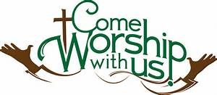

Give Aloha – Mahalo!
Please mail your receipt with your name on it to the church office, so we may credit your giving account properly. Foodland does not provide us with any names. Also, please make sure that the date, time, and store is on the receipt. That is the only way we are able to verify your giving with the printout provided by Foodland.

Continue to keep safe, and help NCC continue their ministries in the community! Thank you in advance for your contribution!
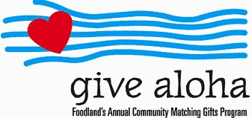

Imu-licious
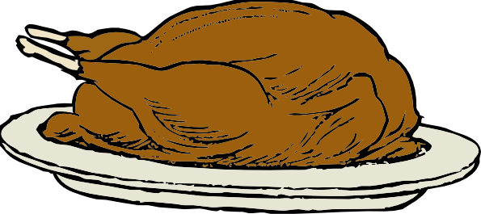
Our friends at City Church of Honolulu have asked for help acquiring turkeys to feed less fortunate families this Thanksgiving. They are getting a crew together to cook them in an imu. So, if you have a Foodland Maika’i Rewards turkey coupon you can share please mail it to the church office. Pastor Jeannie will get them to the City Church folks. Mark the envelope: Pastor Jeannie: Turkeys. If you would also like to help out with the imu, we will have more information soon.

Neighbors in Need
Thank you to all who participated in the annual Neighbors in Need special offering last month. Our church gathered $844.00, which will support ministries of justice and compassion throughout the country. Bless you for your generosity!

59th Nu’uanu Valley Interfaith Thanksgiving Service
Tuesday, November 24, 2020, 7:00 pm
Historic Virtual Event

When: Tuesday, November 24, 2020 7:00 pm Free & Open to the Public

Where: Virtual Zoom Event

2020 Theme: “Bound in Light”

Zoom login information for 11/24
+1 253 215 8782

Meeting ID & Passcode
Meeting ID: 956 5898 7545
Passcode: 523922
Advent Organ Chorales
A Virtual Organ Recital
by Katherine Crosier, organist
Friday, December 7, 2020 • 7:00 pm

The art of hymn introductions was perfected in Germany, where the "chorale prelude" was developed by Johann Sebastian Bach and other north German composers. The chorale prelude is a relatively short setting for organ which is intended to introduce the hymn tune to the congregation. This concert will feature a wide variety of chorale preludes by international composers from Germany, France, Norway, and the United States: Bach, Johann Pachelbel, Hugo Distler, Marcel Dupré, Egil Hovland, Gerald Near and Paul Manz. Four singers will sing the hymns immediately following each chorale prelude.

The concert will be livestreamed and then archived on the Lutheran Church of Honolulu Facebook page on Dec. 7 at 7:00 pm: https://www.facebook.com/LCHwelcome/

Annual Reports Due
To all board and committee chairs, Moderator, and Pastor, please submit your annual reports to Mairi Manley by December 18 via email. Adhering to this deadline will be most appreciated. Reports should be in Word or Pages format, Century Schoolbook font, size 12. Any photos should be sent separately (not within the report). Mahalo.

2020 Contributions
Just a reminder....in order for contributions to be credited for the 2020 tax year, they must be either mailed to the church with a USPS postmark not later than December 31, 2020 or received by the church office before 12:00 p.m. Thursday, December 31, 2019. Contributions received after that will be credited to 2021.

