A Weekly Newsletter of Nu‘uanu Congregational Church
NCC News
October 25, 2020

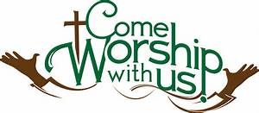

Give Aloha – Mahalo!
Mahalo to all who participated in Foodland’s Give Aloha Program last month. We will be receiving all of your contributions and Foodland’s grant some time in mid-October.

Please mail your receipt with your name on it to the church office, so we may credit your giving account properly. Foodland does not provide us with any names. Also, please make sure that the date, time, and store is on the receipt. That is the only way we are able to verify your giving with the printout provided by Foodland.

Continue to keep safe, and help NCC continue their ministries in the community! Thank you in advance for your contribution!
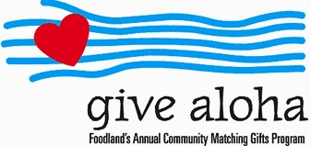

Chutney and Jam Sale
Once again, Donald Ikeda has graciously prepared his popular mango chutney, lilikoi jelly, mango jam, guava jam, and calamondin marmalade. Proceeds will benefit Nu‘uanu Congregational Church. The church is still closed due to the Covid-19 situation, so please use the attached order form. Supplies are limited, so orders will be filled as they are received. Do not mail in your payment, in case it cannot be filled. Your order will be confirmed by phone or email. Payment will be collected at the time of pick up in front of the gym at NCC on Sunday, November 1, 2020 between 9:00-10:00 a.m. Just drive your car up to the designated area. Face mask required.

Blessings and Blessings—November 1st … AT CHURCH!

November 1st is a special day in the life of our church.
It is Communion Sunday, and it is All Saints Sunday.
To make it a special day and memorable day, we have decided
to welcome all to come to church that day for

Drive Through Communion

In addition to Communion, you are invited to bring your dog, cat, fish, or bird for a drive-through
Blessing of the Animals

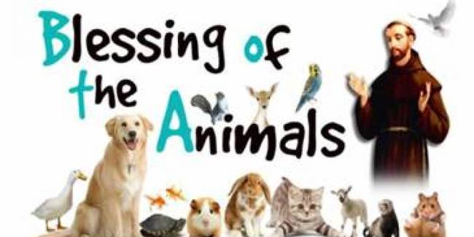

For those who purchased Don Ikeda’s chutney or jam
there will a station to pick-up.

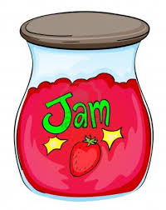

Got Your Flu Shot?
As we enter the flu season, be sure to get your flu shot!

Maybe you think because you are hardly leaving the house, you can skip your flu shot this year? This is a year that we all need to do everything that we can to stay safe and healthy. Even a common flu strain can land you in the hospital, and we need to avoid putting any additional strain on our hospitals this year. Plus, the flu is no fun, and you just don't want to get sick. If you are 65 or older, ask your pharmacist about the enhanced flu shot. And call soon, as it is in short supply. - Judy Keith, Parish Nurse

Family Promise
Covid 19 has changed so much of what we are able to do this year. One of the things that I am missing a lot is NCC being able to host Family Promise. Our next rotation was due on November first. Although congregations are unable to provide housing, the needs of homeless families in our community continue. It should come as no surprise that Family Promise has received a record number of requests for help in 2020. They have needed to be creative and flexible to meet these needs.

Families are currently being housed at Camp Mokuleia on the north shore and at a hotel in Waikiki. Family Promise has asked for our help in providing meals to the families at the Waikiki hotel. The program is no contact. You are asked to:
• Prepare a main dish and a side dish that pairs well with rice. The families each have a rice cooker.
• Pack the food in containers according to family size and label containers with floor and room number. Family Promise will make containers available for your use on request.
• Meet a FPH staff member at the hotel at 5 pm so the meals can be delivered to the families.
Pastor Jeannie has very graciously offered to deliver meals for us. You can contact her at 353-1387. For open dates and additional information contact Marissa Commey at 548-7478 or email at marissa@familypromisehawaii.org.

NCC has been a strong supporter of Family Promise since 2005. Please prayerfully consider whether this is a need that you are able to meet. Despite all the difficulties that 2020 has brought our way, we still have so much to be grateful for this Thanksgiving month. Reaching out to Family Promise is a wonderful way to live out our gratitude, serve the community and serve God.
-Judy Keith

Church Office
The church office has reopened. Keeping our staff safe is a high priority, so please adhere to this protocol. If there is any business that needs to be conducted, please email it to nccadmin@hawaiiantel.net or call the church office for an appointment. If you need to see Pastor Jeannie, she can be reached at 353-1387. Postal and commercial deliveries will be allowed. Face covering is required by anyone entering the office. Before entering the office, please conduct the self-assessment that is posted on the window adjacent to the door. Also, not more than 4 people, including staff, should be in the office at a time. Thank you for your cooperation in keeping everyone safe as possible!

