A Weekly Newsletter of Nu‘uanu Congregational Church
NCC News
October 11, 2020

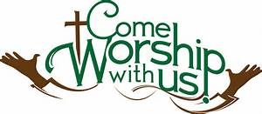

Give Aloha – Mahalo!
Mahalo to all who participated in Foodland’s Give Aloha Program last month. We will be receiving all of your contributions and Foodland’s grant some time in mid-October.

Please mail your receipt with your name on it to the church office, so we may credit your giving account properly. Foodland does not provide us with any names. Also, please make sure that the date, time, and store is on the receipt. That is the only way we are able to verify your giving with the printout provided by Foodland.

Continue to keep safe, and help NCC continue their ministries in the community! Thank you in advance for your contribution!
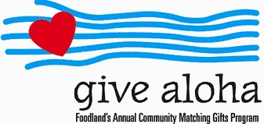

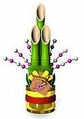
Troop 201 Cancels Kadomatsu Sale
Due to the ongoing circumstances with COVID-19, the Kadomatsu Committee has unanimously decided to cancel this year's production. Yes, Kadomatsu is 3 1/2 months away, but being that the state and federal government still has no solid plan on how to handle the situation, we felt that this is the best decision for the health and safety of our families.

Chutney and Jam Sale
Once again, Donald Ikeda has graciously prepared his popular mango chutney, lilikoi jelly, mango jam, guava jam, and calamondin marmalade. Proceeds will benefit Nu‘uanu Congregational Church. The church is still closed due to the Covid-19 situation, so please use the attached order form. Supplies are limited, so orders will be filled as they are received. Do not mail in your payment, in case it cannot be filled. Your order will be confirmed by phone or email. Payment will be collected at the time of pick up in front of the gym at NCC on Sunday, November 1, 2020 between 9:00-10:00 a.m. Just drive your car up to the designated area. Face mask required.

Blessings and Blessings—November 1st … AT CHURCH!

November 1st is a special day in the life of our church.
It is Communion Sunday, and it is All Saints Sunday.
To make it a special day and memorable day, we have decided
to welcome all to come to church that day for

Drive Through Communion

In addition to Communion, you are invited to bring your dog, cat, fish, or bird for a drive-through
Blessing of the Animals

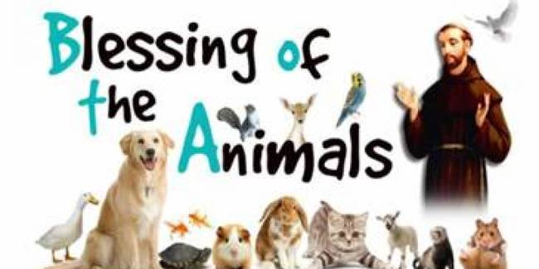

For those who purchased Don Ikeda’s chutney or jam
there will a station to pick-up.

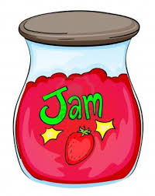

Got Your Flu Shot?
As we enter the flu season, be sure to get your flu shot!

Maybe you think because you are hardly leaving the house, you can skip your flu shot this year? This is a year that we all need to do everything that we can to stay safe and healthy. Even a common flu strain can land you in the hospital, and we need to avoid putting any additional strain on our hospitals this year. Plus, the flu is no fun, and you just don't want to get sick. If you are 65 or older, ask your pharmacist about the enhanced flu shot. And call soon, as it is in short supply. - Judy Keith, Parish Nurse

Church Office
The church office has reopened. Keeping our staff safe is a high priority, so please adhere to this protocol. If there is any business that needs to be conducted, please email it to nccadmin@hawaiiantel.net or call the church office for an appointment. If you need to see Pastor Jeannie, she can be reached at 353-1387. Postal and commercial deliveries will be allowed. Face covering is required by anyone entering the office. Before entering the office, please conduct the self-assessment that is posted on the window adjacent to the door. Also, not more than 4 people, including staff, should be in the office at a time. Thank you for your cooperation in keeping everyone safe as possible!

