A Weekly Newsletter of Nu‘uanu Congregational Church
NCC News
September 27, 2020

Give Aloha – NCC’s Code: 78424 – Only a Few More Days!
September is ending soon, so if you haven’t already made a donation to NCC via Foodland’s Give Aloha Program, hurry down to the store! You can also make a donation online with curbside pick up or home delivery!

This generous program allows you an opportunity to make your contribution to NCC “grow”! You may contribute up to $249/organization/ Maika’i account, and Foodland will match a percentage of that contribution. Yes, the more you give, the more Foodland will match! This is one of their ways of giving back to the community, especially during this time of need!

Also, don’t forget to mail your receipt right away to the church office with your name on it, so we may credit your giving statement. Foodland does not provide the church with any names.

Continue to keep safe, and help NCC continue their ministries in the community! Thank you in advance for your contribution!
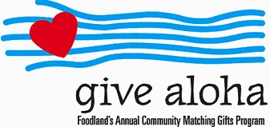

Troop 201 Cancels Kadomatsu Sale
Due to the ongoing circumstances with COVID-19, the Kadomatsu Committee has unanimously decided to cancel this year's production. Yes, Kadomatsu is 3 1/2 months away, but being that the state and federal government still has no solid plan on how to handle the situation, we felt that this is the best decision for the health and safety of our families.

Church Office
The church office has reopened. Keeping our staff safe is a high priority, so please adhere to this protocol. If there is any business that needs to be conducted, please email it to nccadmin@hawaiiantel.net or call the church office for an appointment. If you need to see Pastor Jeannie, she can be reached at 353-1387. Postal and commercial deliveries will be allowed. Face covering is required by anyone entering the office. Before entering the office, please conduct the self-assessment that is posted on the window adjacent to the door. Also, not more than 4 people, including staff, should be in the office at a time. Thank you for your cooperation in keeping everyone safe as possible!

