A Weekly Newsletter of Nu‘uanu Congregational Church
NCC News
September 20, 2020

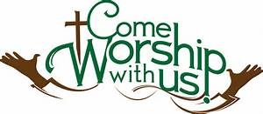

Give Aloha – NCC’s Code: 78424
Give Aloha, Foodland’s Community Matching Program is for the entire month of September. If you don’t already have a Maika’i card, you can get one at any Foodland or Sack n Save store. It’s free! You just need a phone number.

This generous program allows you an opportunity to make your contribution to NCC “grow”! You may contribute up to $249/organization/ Maika’i account, and Foodland will match a percentage of that contribution. Yes, the more you give, the more Foodland will match! This is one of their ways of giving back to the community, especially during this time of need!

Also, don’t forget to mail your receipt right away to the church office with your name on it, so we may credit your giving statement. Foodland does not provide the church with any names.

Continue to keep safe, and help NCC continue their ministries in the community! Thank you in advance for your contribution!

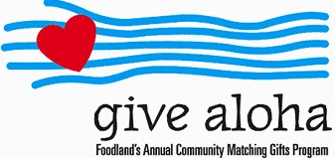

Stay at Home/Work from Home Order Extended
Mayor Caldwell has issued an extended two-week “Stay at Home/Work from Home” order for the island of Oahu. This order is effective 12:01 a.m. Thursday, September 10, 2020. The church office will be closed during this duration.

If there is any business that needs to be conducted, please email it to nccadmin@hawaiiantel.net. The USPS mail will be checked periodically.

Let’s do our part to lessen the curve and observe the “3 W’s”:
Wash your hands frequently,
Watch your distance - stay 6 feet away, avoid large groups, and
Wear a face mask.

With each person’s commitment to doing our part in lessening the curve, we can reset and reopen our community. We can do this. We did it before.

