A Weekly Newsletter of Nu‘uanu Congregational Church
NCC News
August 23, 2020

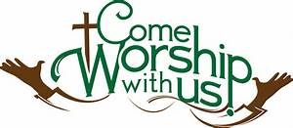

In-Person Worship Suspended
Due to the recent surge in Covid-19 cases on Oahu, the Diaconate has temporarily suspended in-person worship services until further notice. You may go to our website, e-News, or Facebook to access our online services.

Give Aloha – NCC’s Code: 78424
Give Aloha, Foodland’s Community Matching Program, begins next Tuesday, September 1, for the entire month of September. If you don’t already have a Maika’i card, you can get one at any Foodland or Sack n Save store. It’s free! You just need a phone number.

This generous program allows you an opportunity to make your contribution to NCC “grow”! You may contribute up to $249 per Maika’i account, and Foodland will match a percentage of that contribution. Yes, the more you give, the more Foodland will match! This is one of their ways of giving back to the community, especially during this time of need!

Also, don’t forget to mail in your receipt right away to the church office with your name on it, so we may credit your giving statement. Foodland does not provide the church with any names.

Continue to keep safe, and help NCC continue their ministries in the community! Thank you in advance for your contribution!

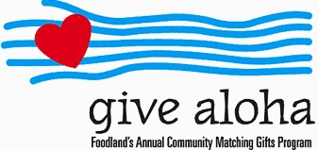

In Loving Memory
Our deepest condolences go out to the family of Alice Ishihara who passed away on August 1, 2020. Alice is survived by husband Howard, son Mark, and grandson Kiyo Matsumoto. She was pre-deceased by daughter Ruth Matsumoto. Please keep the Ishihara family in your prayers.

Applicants Wanted for NCC Administrative Coordinator Position
Paula Yamamoto, our long-time Administrative Coordinator, has (sadly!) announced her desire to retire. We all appreciate Paula's faithful service and wish her a happy upcoming retirement!

We are, consequently, seeking qualified applicants for the position. The position performs many essential functions, which include among others:
(1) coordinates the church’s and facility users’ activities and keeps the church’s master calendar,
(2) supports the Pastor and Moderator with administrative duties, record-keeping, financial management, and communications,
(3) takes and screens incoming calls and inquiries to the church, and receives and processes the incoming mail,
(4) types the publication of church communications, including the worship bulletin, PowerPoint, newsletters, and e-news,
(5) orders office and janitorial supplies, and assures the maintenance and upkeep of church equipment and computer network, and
(6) updates the church’s website and social media platforms.

Applicants should have a college degree or two to four years of equivalent related experience and/or training, and strong communication and interpersonal skills. Applicants must be able to keep information confidential, to work independently with little or minimal supervision, and to problem solve and work cooperatively with others. Also, applicants should demonstrate an ability to use both PC and Mac platforms and other software.

Interested applicants should send their resume to Nu‘uanu Congregational Church at nccadmin@hawaiiantel.net. No phone calls, please. - Stanley Chong

